[--->Step 1: I login as an admin user[FAILED]<---]
  
[--->Failed Reason:
org.openqa.selenium.NoSuchElementException: no such element: Unable to locate element: {"method":"css selector","selector":"*[name='username']"}
(Session info: chrome=100.0.4896.127)
For documentation on this error, please visit: https://selenium.dev/exceptions/#no_such_element
Build info: version: '4.6.0', revision: '79f1c02ae20'
System info: os.name: 'Mac OS X', os.arch: 'aarch64', os.version: '13.0.1', java.version: '11.0.18'
Driver info: org.openqa.selenium.remote.RemoteWebDriver
Command: [2b0f30e9732bb72957c85f1e429ca4a7, findElement {using=name, value=username}]
Capabilities {acceptInsecureCerts: false, browserName: chrome, browserVersion: 100.0.4896.127, chrome: {chromedriverVersion: 100.0.4896.60 (6a5d10861ce8..., userDataDir: C:\Users\ltuser\AppData\Loc...}, goog:chromeOptions: {debuggerAddress: localhost:59330}, goog:loggingPrefs: {browser: ALL}, networkConnectionEnabled: false, pageLoadStrategy: normal, performance: false, platformName: WINDOWS, proxy: Proxy(), se:cdpVersion: 100.0.4896.127, setWindowRect: true, strictFileInteractability: false, timeouts: {implicit: 0, pageLoad: 300000, script: 30000}, unhandledPromptBehavior: dismiss and notify, video: true, webauthn:extension:credBlob: true, webauthn:extension:largeBlob: true, webauthn:virtualAuthenticators: true}
Session ID: 2b0f30e9732bb72957c85f1e429ca4a7
at java.base/jdk.internal.reflect.NativeConstructorAccessorImpl.newInstance0(Native Method)
at java.base/jdk.internal.reflect.NativeConstructorAccessorImpl.newInstance(NativeConstructorAccessorImpl.java:62)
at java.base/jdk.internal.reflect.DelegatingConstructorAccessorImpl.newInstance(DelegatingConstructorAccessorImpl.java:45)
at java.base/java.lang.reflect.Constructor.newInstance(Constructor.java:490)
at org.openqa.selenium.remote.codec.w3c.W3CHttpResponseCodec.createException(W3CHttpResponseCodec.java:200)
at org.openqa.selenium.remote.codec.w3c.W3CHttpResponseCodec.decode(W3CHttpResponseCodec.java:133)
at org.openqa.selenium.remote.codec.w3c.W3CHttpResponseCodec.decode(W3CHttpResponseCodec.java:53)
at org.openqa.selenium.remote.HttpCommandExecutor.execute(HttpCommandExecutor.java:184)
at org.openqa.selenium.remote.TracedCommandExecutor.execute(TracedCommandExecutor.java:51)
at org.openqa.selenium.remote.RemoteWebDriver.execute(RemoteWebDriver.java:541)
at org.openqa.selenium.remote.ElementLocation$ElementFinder$2.findElement(ElementLocation.java:162)
at org.openqa.selenium.remote.ElementLocation.findElement(ElementLocation.java:66)
at org.openqa.selenium.remote.RemoteWebDriver.findElement(RemoteWebDriver.java:365)
at org.openqa.selenium.remote.RemoteWebDriver.findElement(RemoteWebDriver.java:357)
at org.openqa.selenium.support.pagefactory.DefaultElementLocator.findElement(DefaultElementLocator.java:70)
at org.openqa.selenium.support.pagefactory.internal.LocatingElementHandler.invoke(LocatingElementHandler.java:39)
at com.sun.proxy.$Proxy29.sendKeys(Unknown Source)
at com.resumelibrary.admintest.misc.MiscPage.loginAsAdminUser(MiscPage.java:116)
at com.resumelibrary.cucumber.stepdefinitions.admin.misc.Misc.iLoginAsAnAdminUser(Misc.java:31)
at ✽.I login as an admin user(file:///Users/shubhamr/Downloads/rl-selenium-web/./src/test/java/resources/featurefiles/aaajobposting/AADataSetup.feature:6)
<---]  
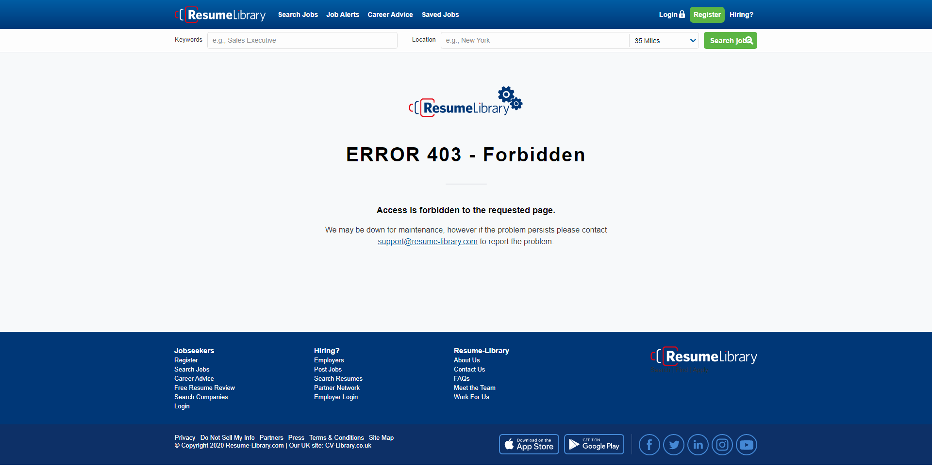

[--->Step 2: I navigate to page on admin "Account 1478"[SKIPPED]<---]

[--->Step 3: I click on product details Edit button[SKIPPED]<---]

[--->Step 4: the job posting spend type is "ACCOUNT" not "CLIENT"[SKIPPED]<---]